**PROJECT TITILE :**

**IDENTIFYING PATTERNS AND TRENDS IN CAMPUS PLACEMENT DATA USING MACHINE LEARNING**

**TEAM NAME : JACKSPARROW**

**TEAM LEADER :**

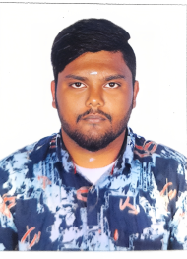

**GOBINATH S**

**TEAM MEMBERS :**

1. **POOMIKA.M**
2. **VALARMATHI.M**
3. **SIVANESAN.T**